
a
Company
Logotype

Cone Beam Computed Tomography- Report



Porur Dental X-rays & CBCT

Patient Name : Mrs. Shanthina | Date of Report : 24.04.2024
Age/ Gender : 43 years/ Female | Region of Interest : CBCT Full Skull
Referring doctor: Dr. Jasher | Indication : Implant assessment
Clinical Notes: Nil
PATIENT INFORMATION

CBCT- Full Skull provided
CBCT – IMAGE DETAILS

RADIOGRAPHIC INTERPRETATION

- Completely missing crown and root portion in relation to 12, 15, 16, 17, 18, 22, 26, 28.
- The maxillary alveolar ridge is present with normal trabecular pattern.

IMPLANT ASSESSMENT

 | 12 region | 22 region
Sub-Crestal | 4.75 | 3.67
Mid- Crestal | 5.33 | 4.59
Distance between the alveolar ridge and Floor of the Nasal cavity (in mm) | 18.17 | 16.88

 | 15 region | 16 region | 17 region | 26 region
Sub-Crestal (in mm) | 4.71 | 4.72 | 4.57 | 6.12
Mid- Crestal (in mm) | 5.65 | 5.39 | 6.33 | 7.12
Distance between the alveolar ridge and floor of the maxillary sinus (in mm) | 12.56 | 10.86 | 5.64 | 14.03

RADIOGRAPHIC IMPRESSION

- Partially edentulous maxillary arch.

Kindly correlate with clinical findings


IMAGES FOR REFERENCE

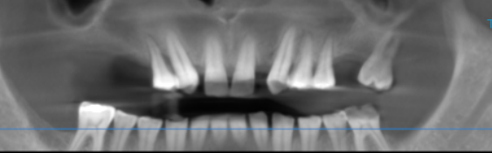

3-DIMENSIONAL VIEW

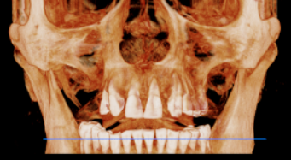

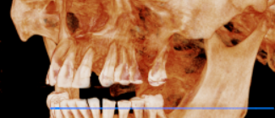
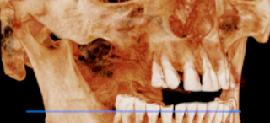

CROSS SECTIONAL VIEW

12 region | 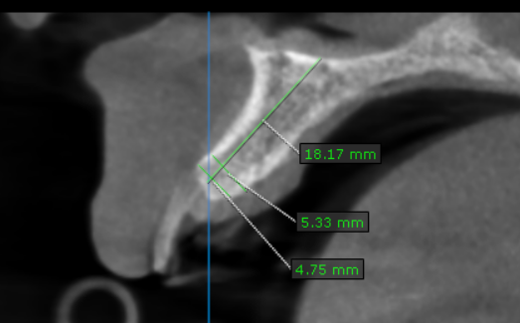
15 region | 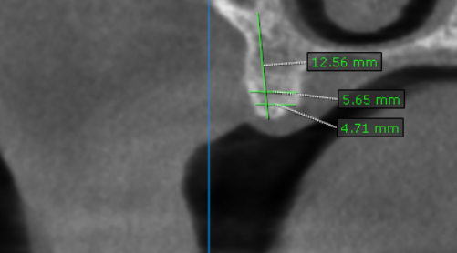
16 region | 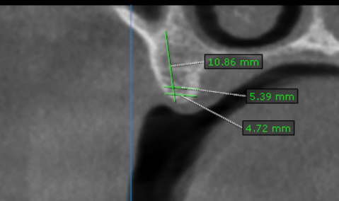
17 region | 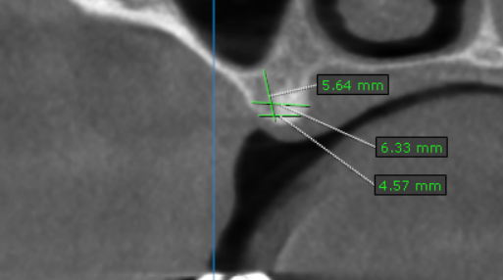
22 region | 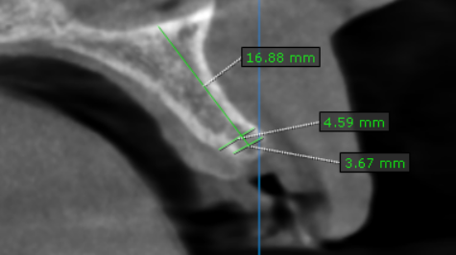
26 region | 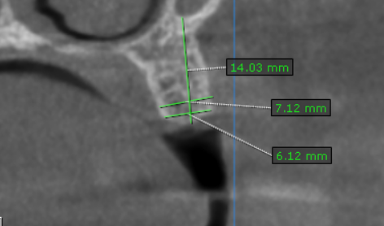

**** End of report ****

